Suggestions for the graphical Layout

1 - Suggestions for the Header
- The login status of the visitor is indicated at the left side of the header. When the visitor is logged in, the [you are not logged in] will be replaced by [Welcome visitor-name].

Visitor is not logged in:
Administrator logged in:

2 - Suggestions for the static Banner
- Euro-Mediterranean map as background of the portal main title.
- Ability to add series of images (up to 4 thumbnails) in the left side of the banner

3 - Toolbar (Quick access, Breadcrumb, Search site)
- The height of this area should the thin as possible
- The quick access and site search are icon-based (a tool tip displayed on mouse over the control will explain the feature to the visitor). In a general way, when the visitor moves its cursor over an icon or an area, a tooltip should display a help text on the feature.

4 - Suggestion for the Main menu
- Location: under the static banner,
- Highlight the selected item on mouse over,
- The text color of the selected item is to be defined,
- The language selection ( [English]) will be located on right side of the main menu.

5 - Suggestion for the Contextual menu
- located in the left side
- derived from the (proposal n°1). Colors and icons are to be defined.
- Partner’s logos go at the bottom
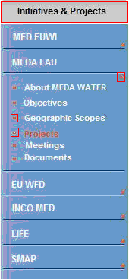

6 - Portlets
- The width of the portlets as suggested for the proposal n°3 is OK.
- The GUI (icons and strong titles) of the portlets as suggested in proposal n°1 is OK
- A e-Flash portlet is added. This portlet also propose the visitor to register to receive the Emwis Flash: the system should propose prompt the visitor to create an account.

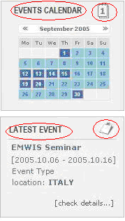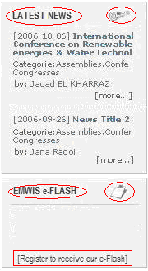

8 - Central area (where goes dynamic contents)
- Adobe icon is added (along with the print and email)
- The update date of the current displayed content should be indicated et the bottom of the central area .
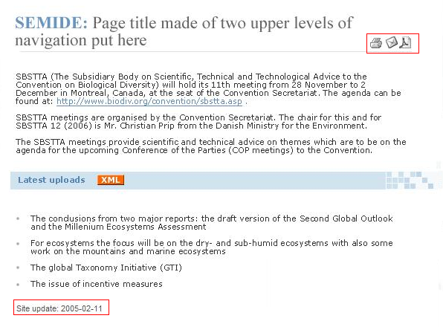
7 – Suggestion for the Footer
- The site update date is moved form the footer in the central area.

